Project Planning Phase
Project Planning Template
Date | 5 September 2026
Student Name | Bantupalli Niharika
Project Name | Automated Network Request Management
Maximum Marks

Product Backlog, Sprint Schedule and Estimation
Sprint | Functional Requirement (Epic) | User Story / Task | Story Points | Priority | Student Name
Sprint-1 | Foundation | Create Network Request application, tables, and required fields. | 6 | High | Ambica Tenagala
Sprint-2 | Catalog & Rules | Create Network Request Catalog Item, variables, UI Policies, and validations. | 6 | High | Ambica Tenagala
Sprint-3 | Automation | Configure approvals, Flow Designer, and Network Task creation. | 6 | High | Ambica Tenagala
Sprint-4 | Validation | Testing, request tracking, and documentation. | 2 | High | Ambica Tenagala
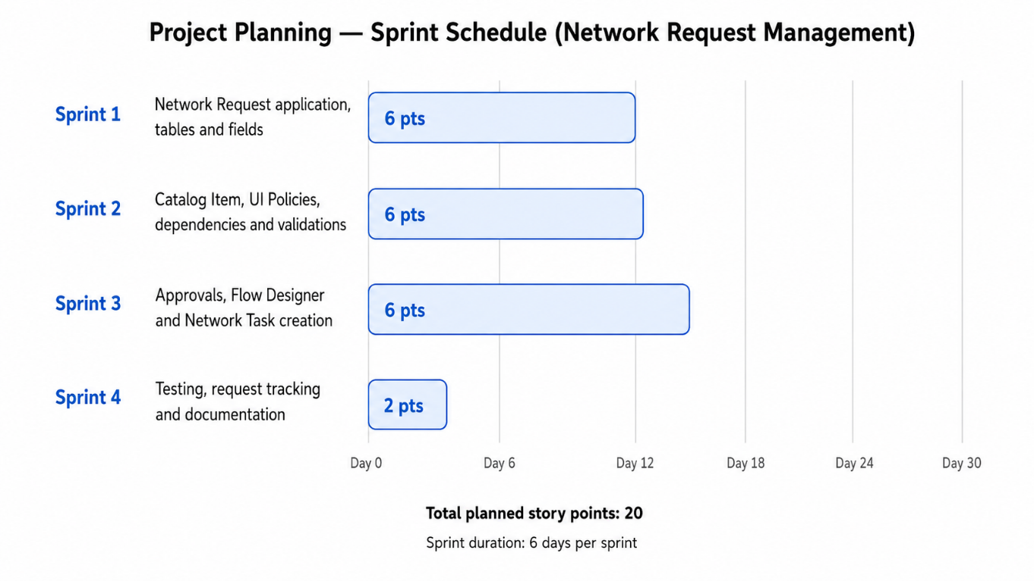

Project Tracker
Work Item | Status | Validation
Network Request Catalog | Completed | Catalog item created successfully.
Catalog Variables | Completed | Required request fields configured.
UI Policies | Completed | Fields validated dynamically.
Approval Process | Completed | Request approval configured.
Flow Designer | Completed | Automation flow configured.
Network Tasks | Completed | Tasks created for fulfillment.
Service Portal | Completed | Network Request available to users.
Testing | Completed | Request submission and workflow validated.

